UPT  
  
Very High Volume

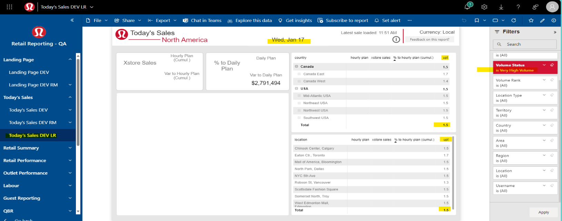  
  
High Volume  
  
  
